Project Design Phase Solution Architecture

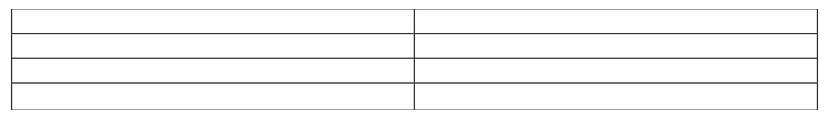Date Team ID

Project Name Maximum Marks

23 june 2025

LTVIP2025TMID49805

VisualizingHousingMarketTrendsAnAnalysisof Sale Prices and Features using Tableau

4 Marks



* **Example - Solution Architecture Diagram:**

